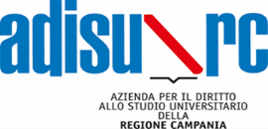

MODEL RELEASE

PHOTOGRAPHIC CONTEST “Diario dalle residenze: raccontare il luogo”

I, the Undersigned (Surname and First Name of the Subject filmed) ......................………………………………...........

born in ………......................................................…………..................on............................................

address .....................................Country………………

I AUTHORIZE

the publication of my image taken by (photographer name)……………………………………………………...
…………………………………………………………………………………………………………………..

I also prohibit its use in contexts that harm my personal dignity and decorum. The posing and use of the images are to be considered done free of charge.

Place and Date .................................................

The Photographed Subject (Surname and First name legible) .............…………………………..................

The Photographer (legible signature) …………………………………………………………..

PRIVACY POLICY
Pursuant to GDPR - Regulation for the protection of personal data, we inform you that the data you provide will be processed as part of the institutional activity of the organizing body exclusively for the purpose of the optimal conduct of the initiative in question. Article 7 of the same law gives you in any case the exercise of specific rights of verification, rectification or cancellation, which can be asserted at any time against the Organizing, responsible for the processing of personal data provided.

The photographed subject

......................................................................................................

